**LAB 2A:** Basic Static Techniques

**Course Name**: Malware Analysis and Reverse Engineering (IAM302)

**Student Name**: Nguyễn Trần Vinh – SE160258

**Instructor Name**: Mai Hoàng Đỉnh

**Lab Due Date**: 11/1/2023

**Purpose**

You will practice the techniques in chapter 1.

What you need:

* A Windows computer (real or virtual) with an Internet connection
* Recommended: the textbook: "Practical Malware Analysis"

**VirusTotal**

* Lab01-01.dll

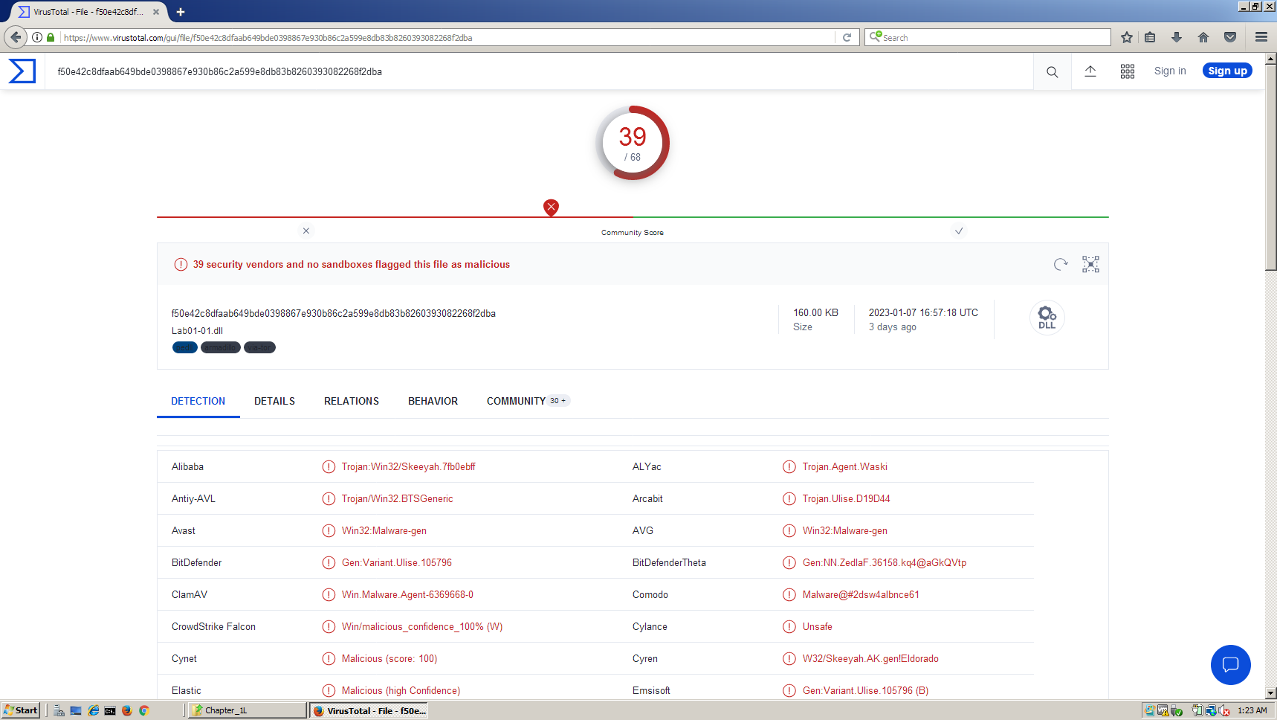 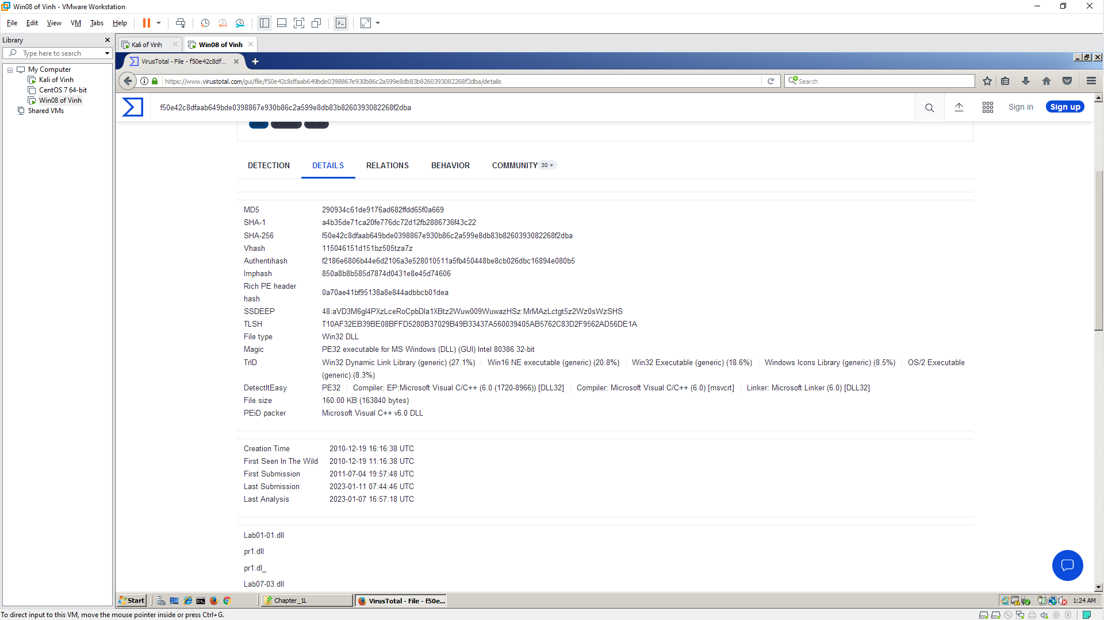 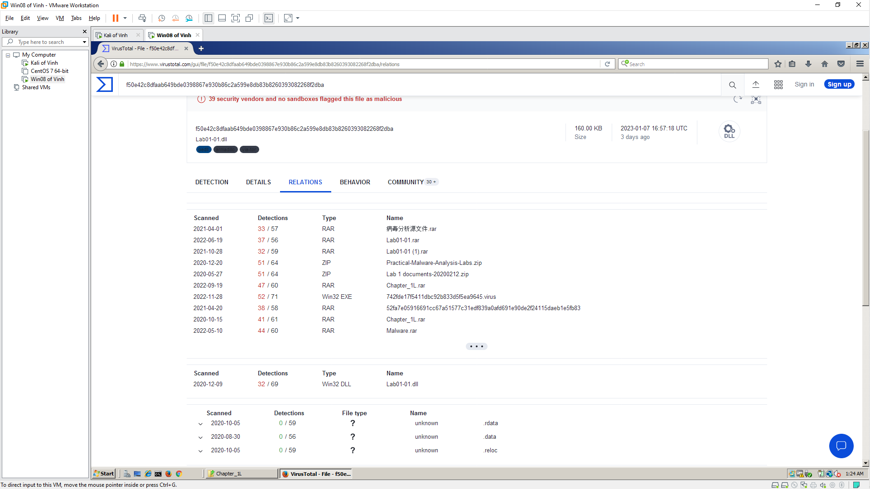

**PEview**

* **Lab01-01.exe**

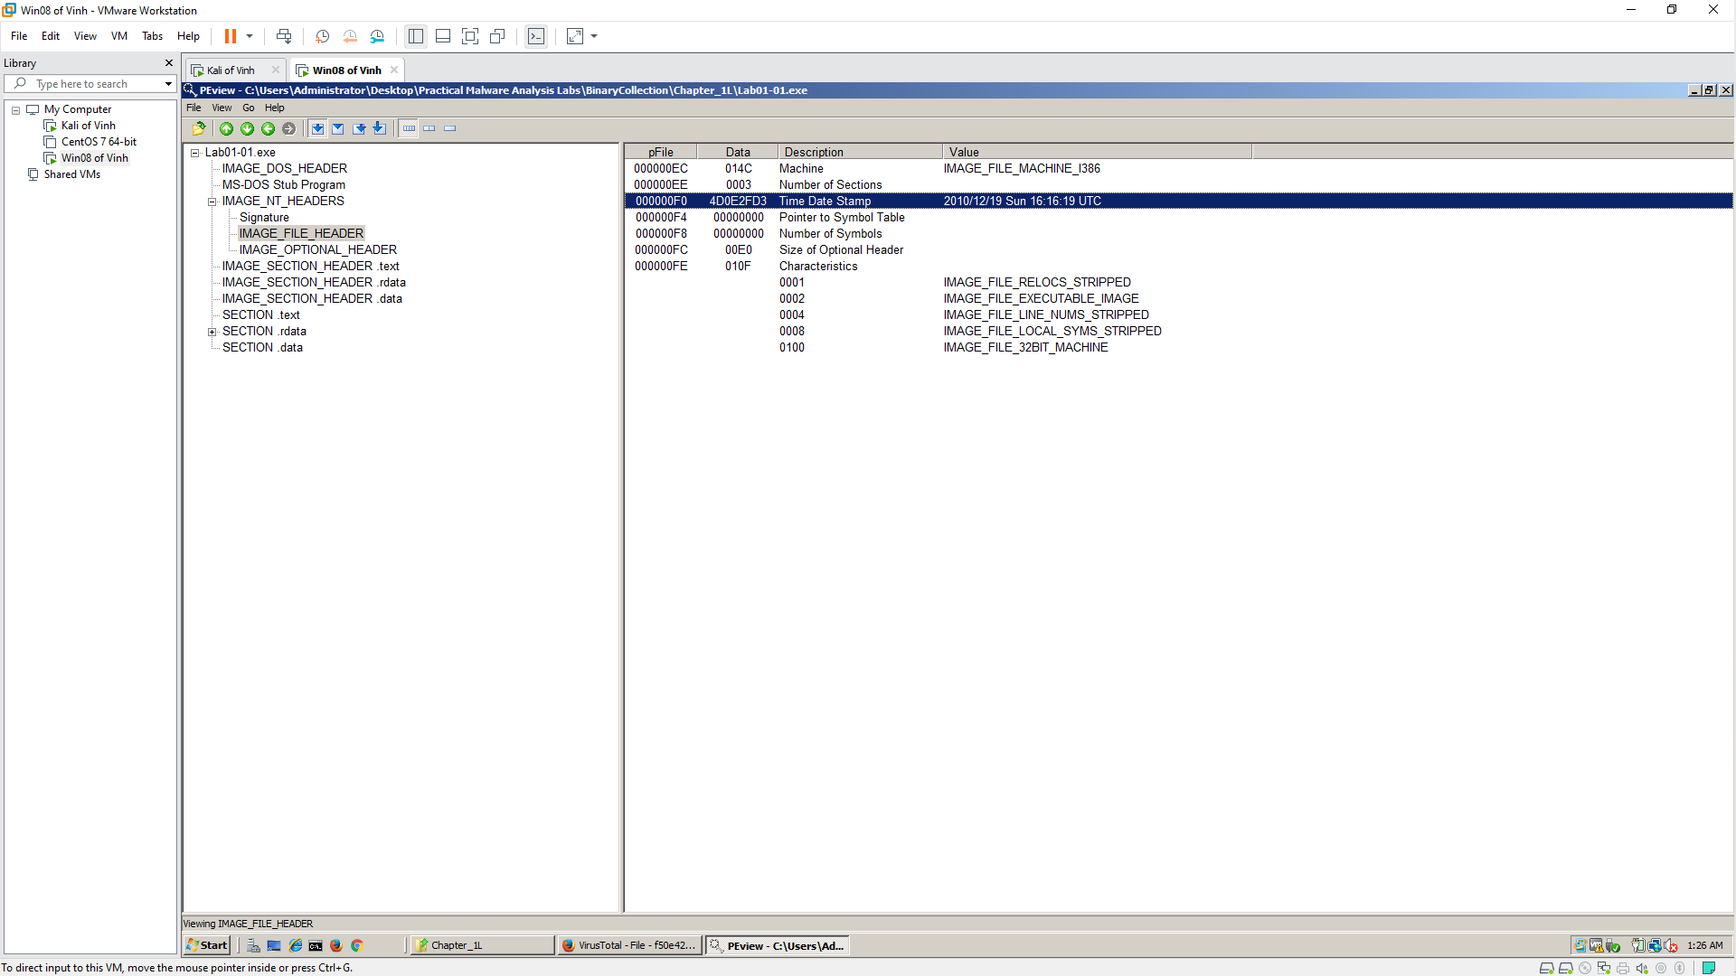

**PEiD**

* Lab01-01.dll

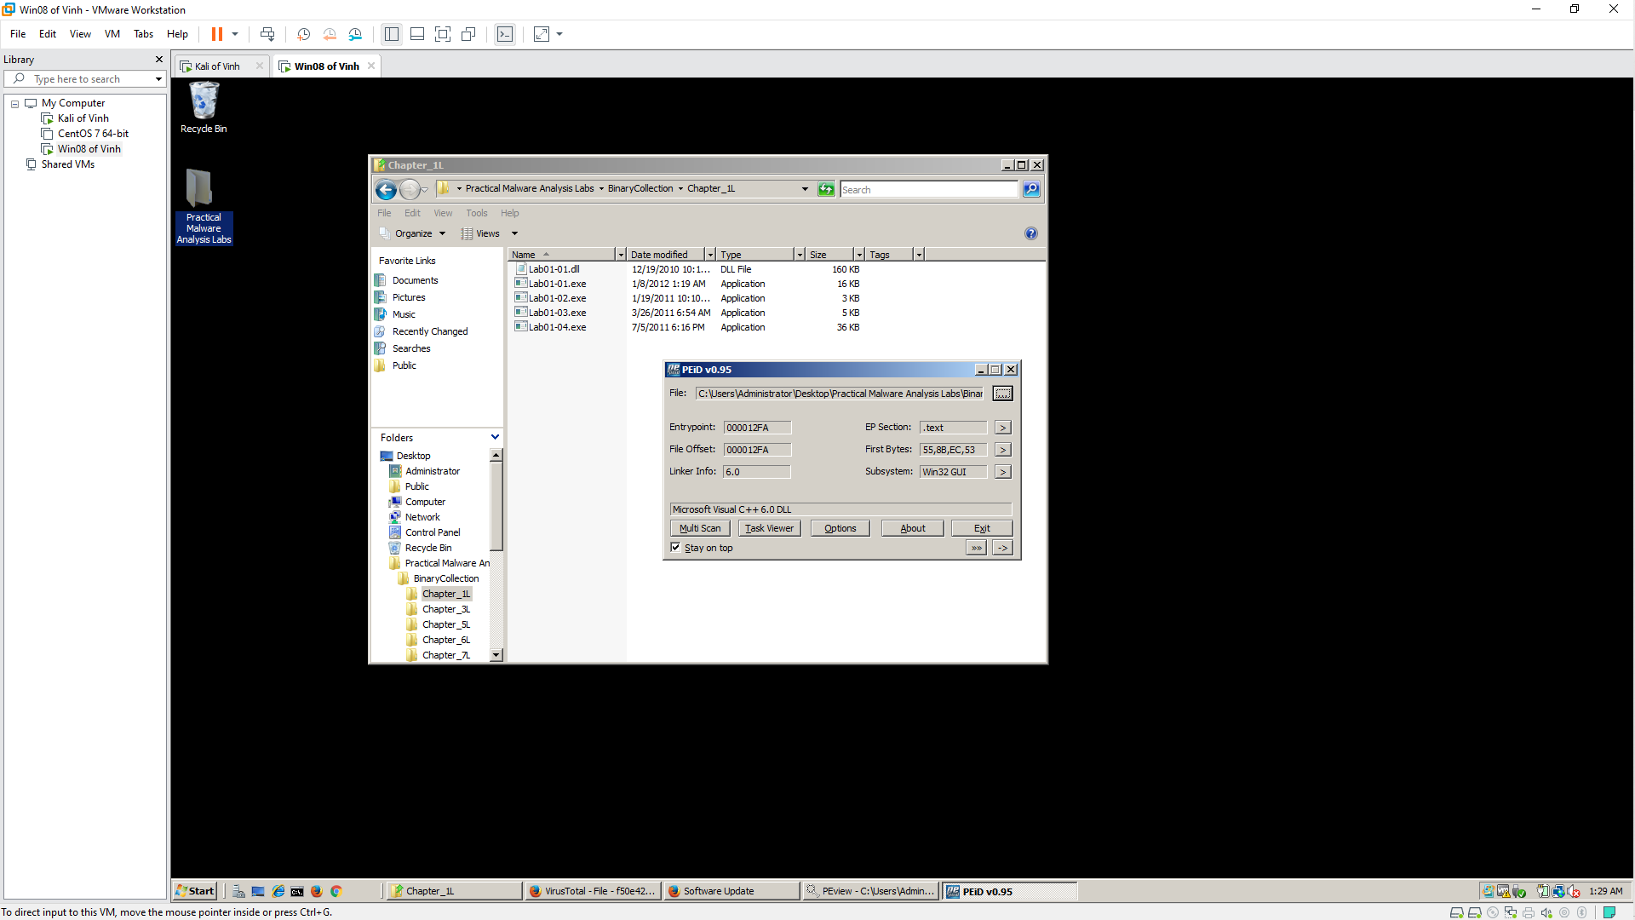

**Strings**

* **Lab01-01.exe**

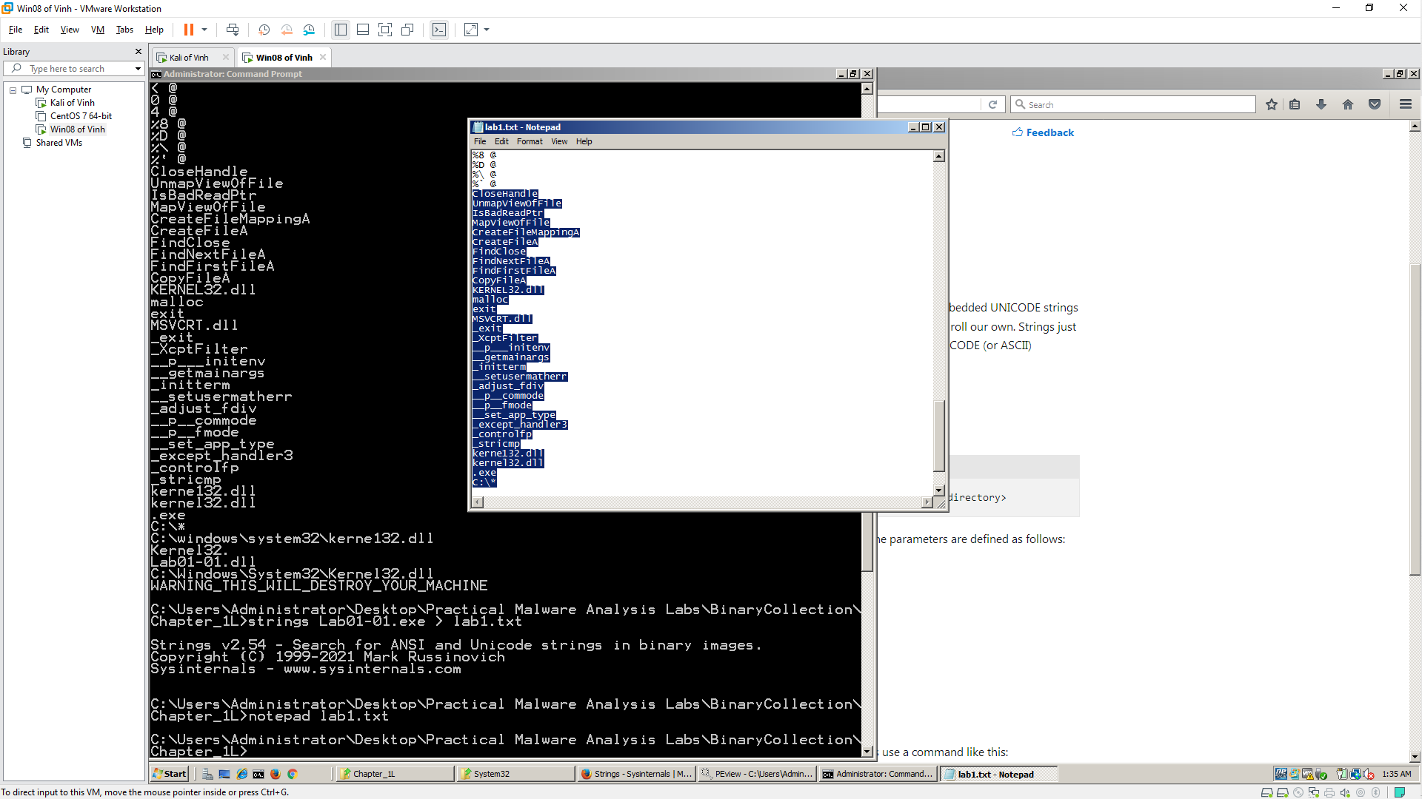

* **Lab01-01.dll**

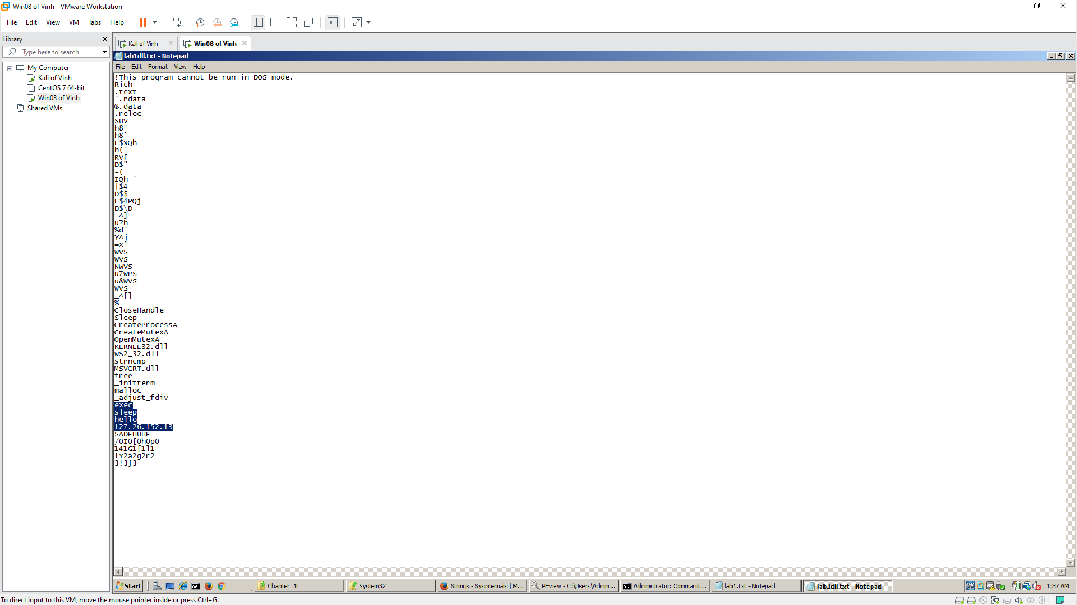

**Dependency Walker**

* **Lab01-01.exe**

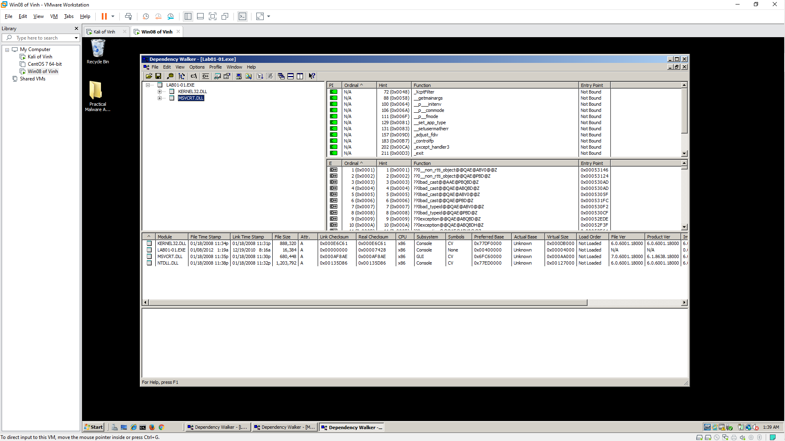 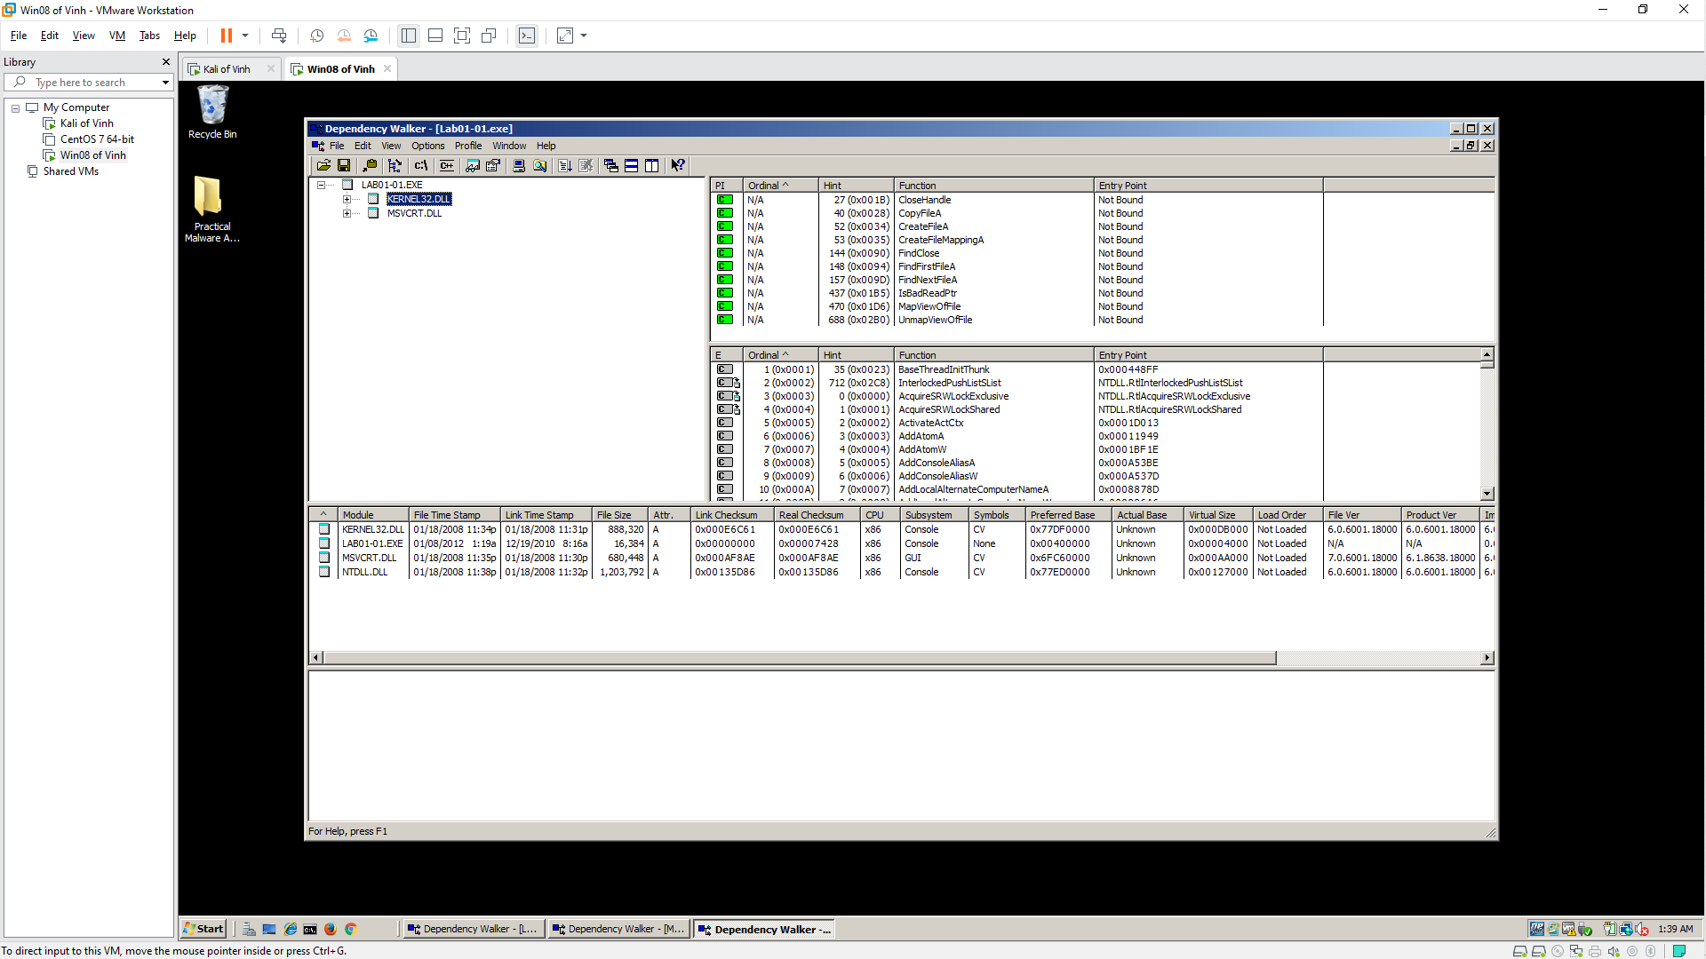

* **Lab01-01.dll**

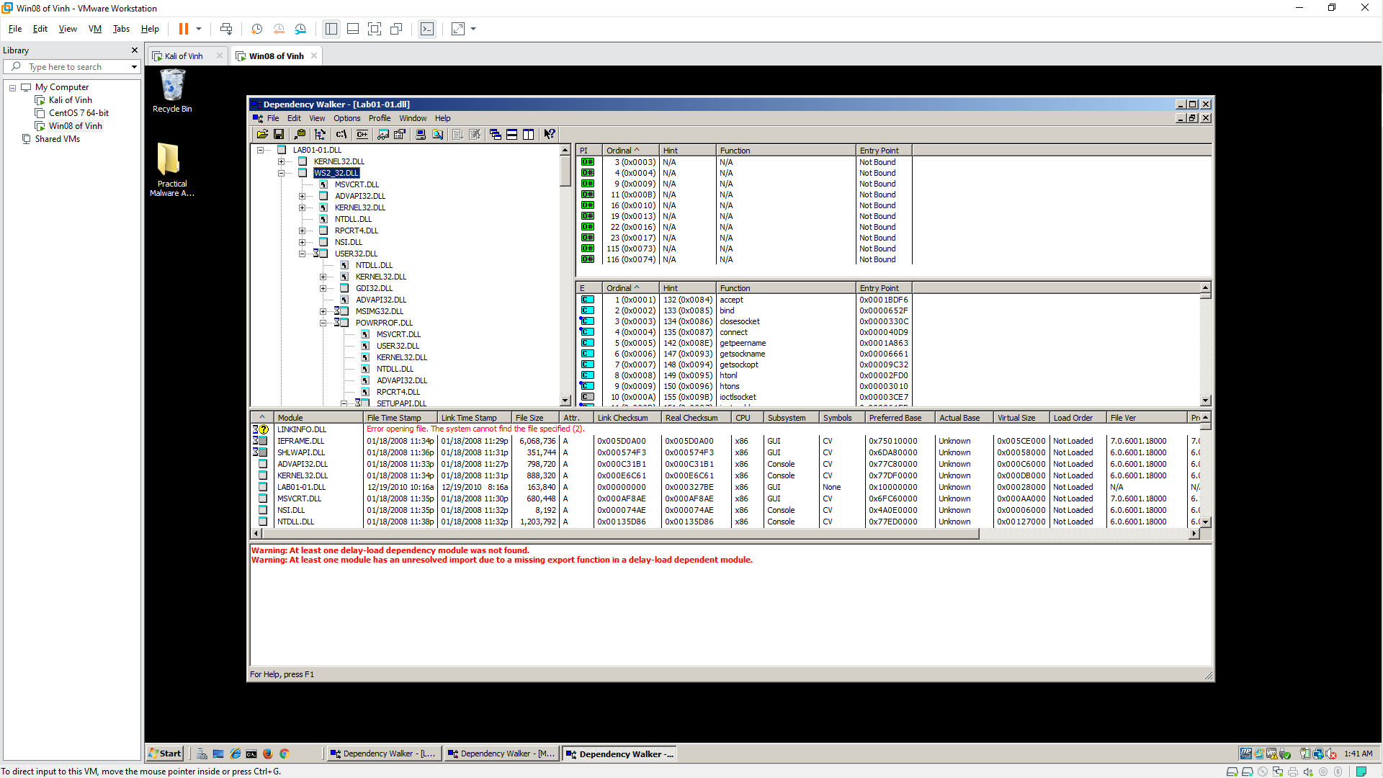

**LAB 2B:** Basic Static Techniques

**Course Name**: Malware Analysis and Reverse Engineering (IAM302)

**Student Name**: Nguyễn Trần Vinh – SE160258

**Instructor Name**: Mai Hoàng Đỉnh

**Lab Due Date**: 11/1/2023

**Purpose**

You will practice the techniques in chapter 1. This project follows Lab 1-2 in the textbook. There are more detailed solutions in the back of the book.

What you need:

* A Windows computer (real or virtual) with an Internet connection
* Recommended: the textbook: "Practical Malware Analysis"

**VirusTotal**

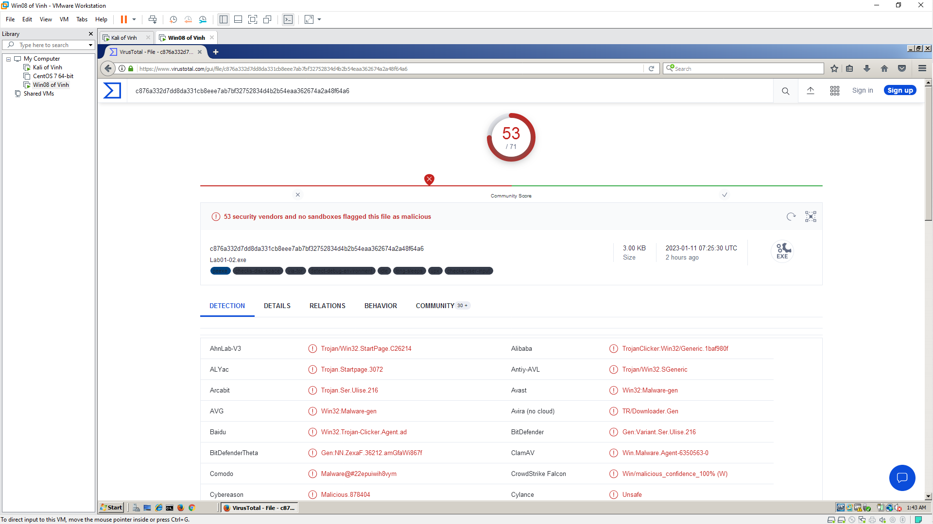 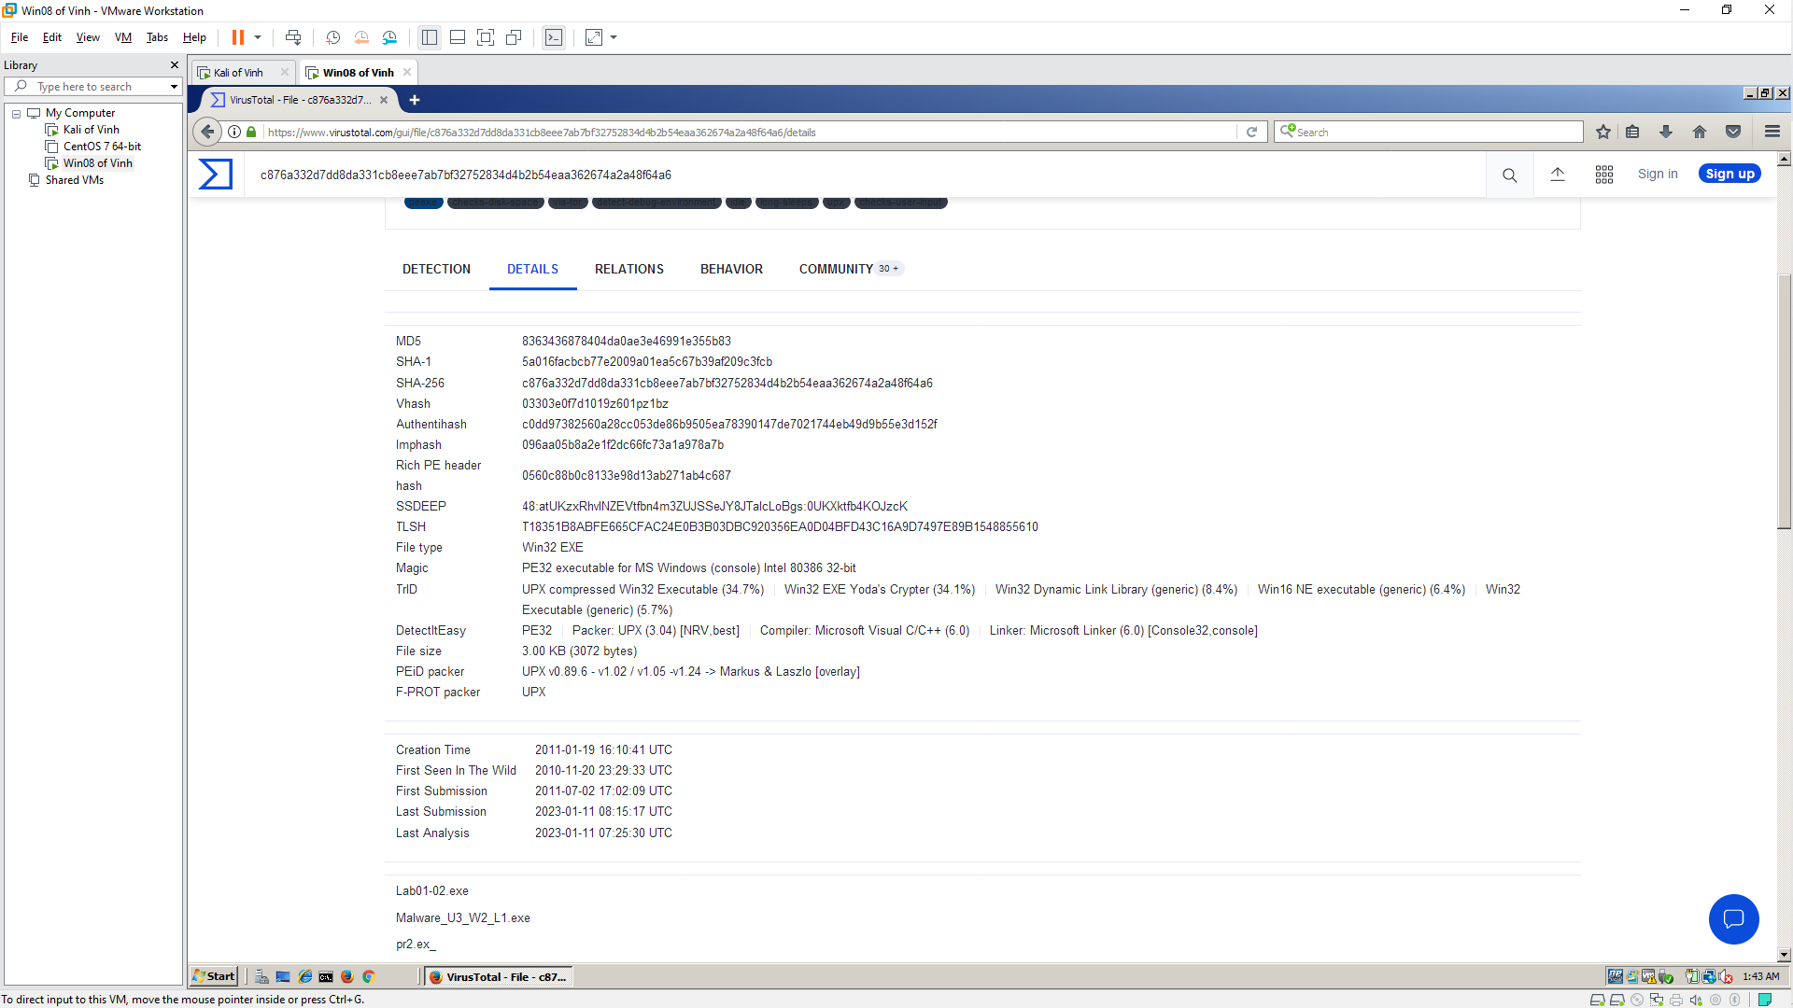 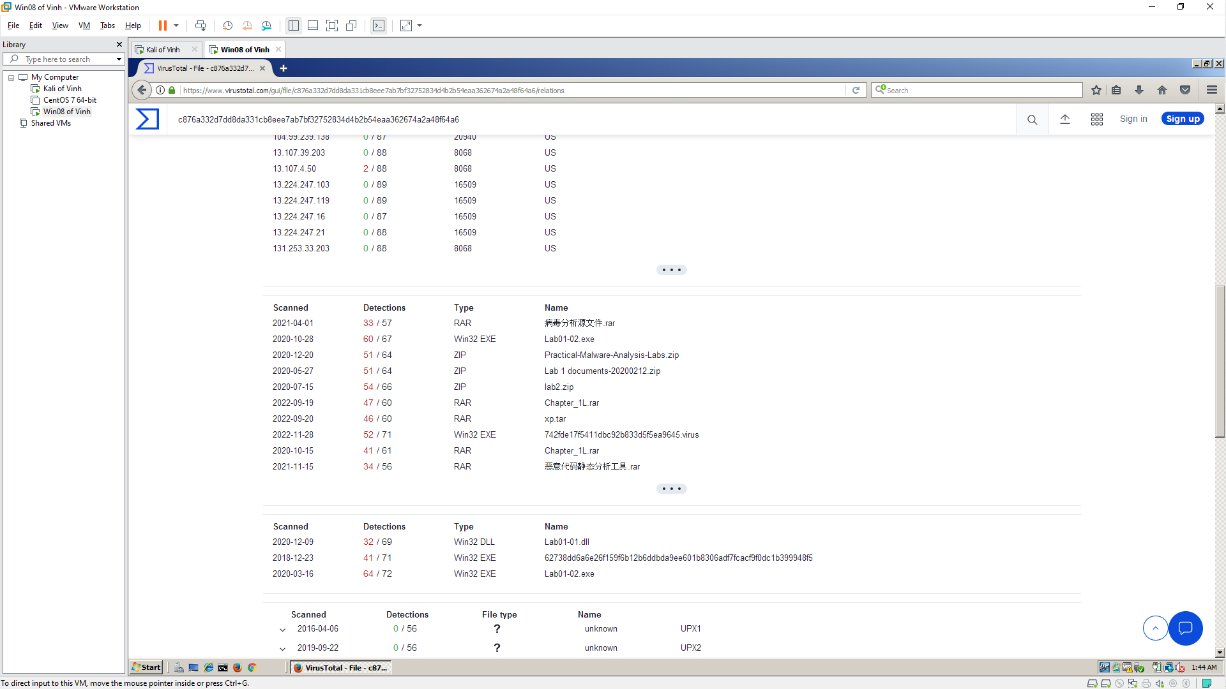

**Unpacking the File**

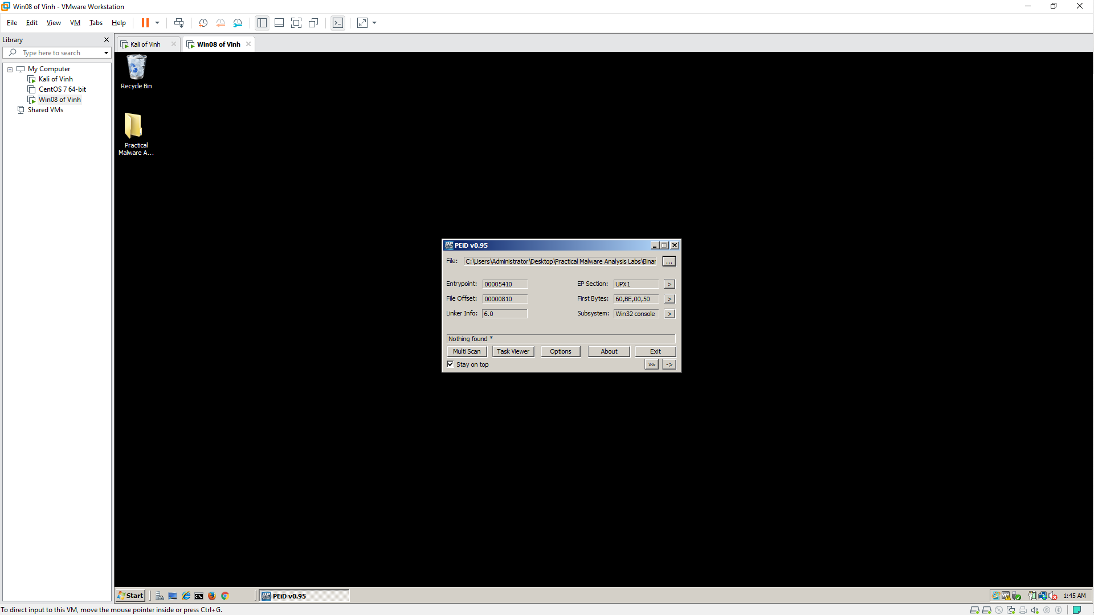 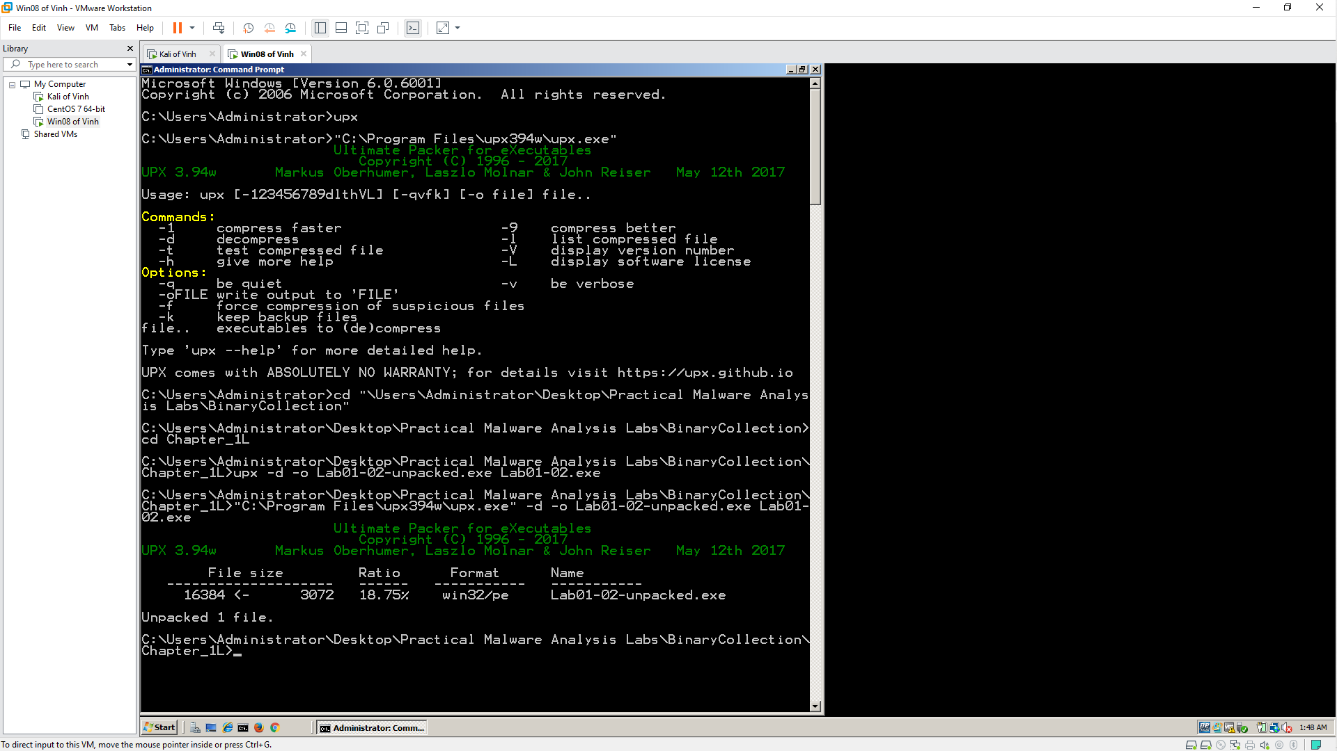 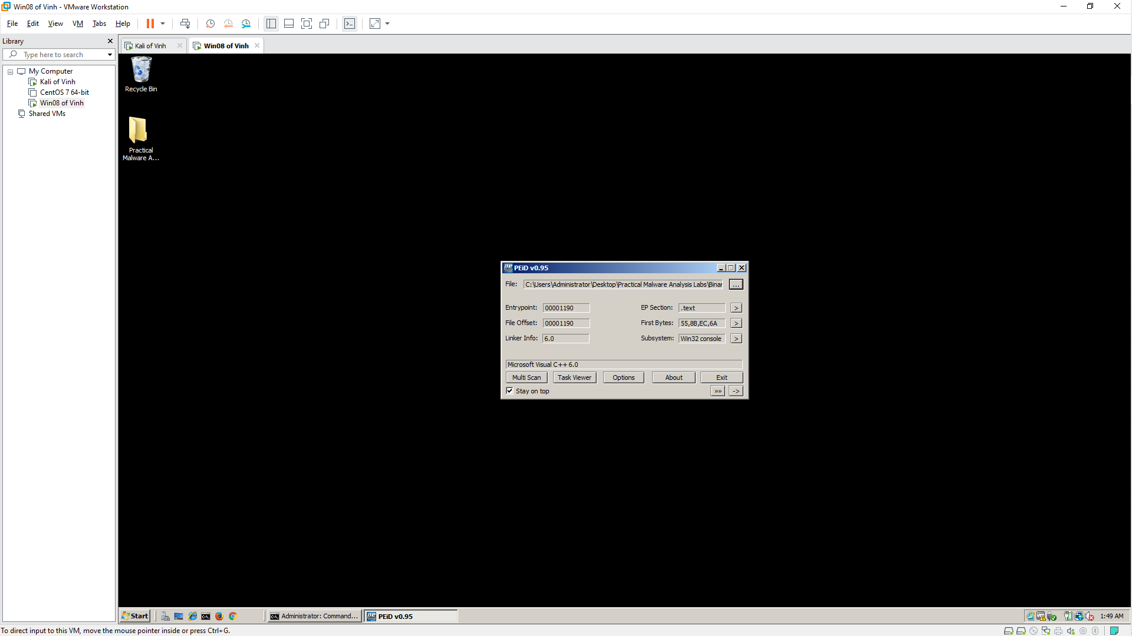

**Imports**

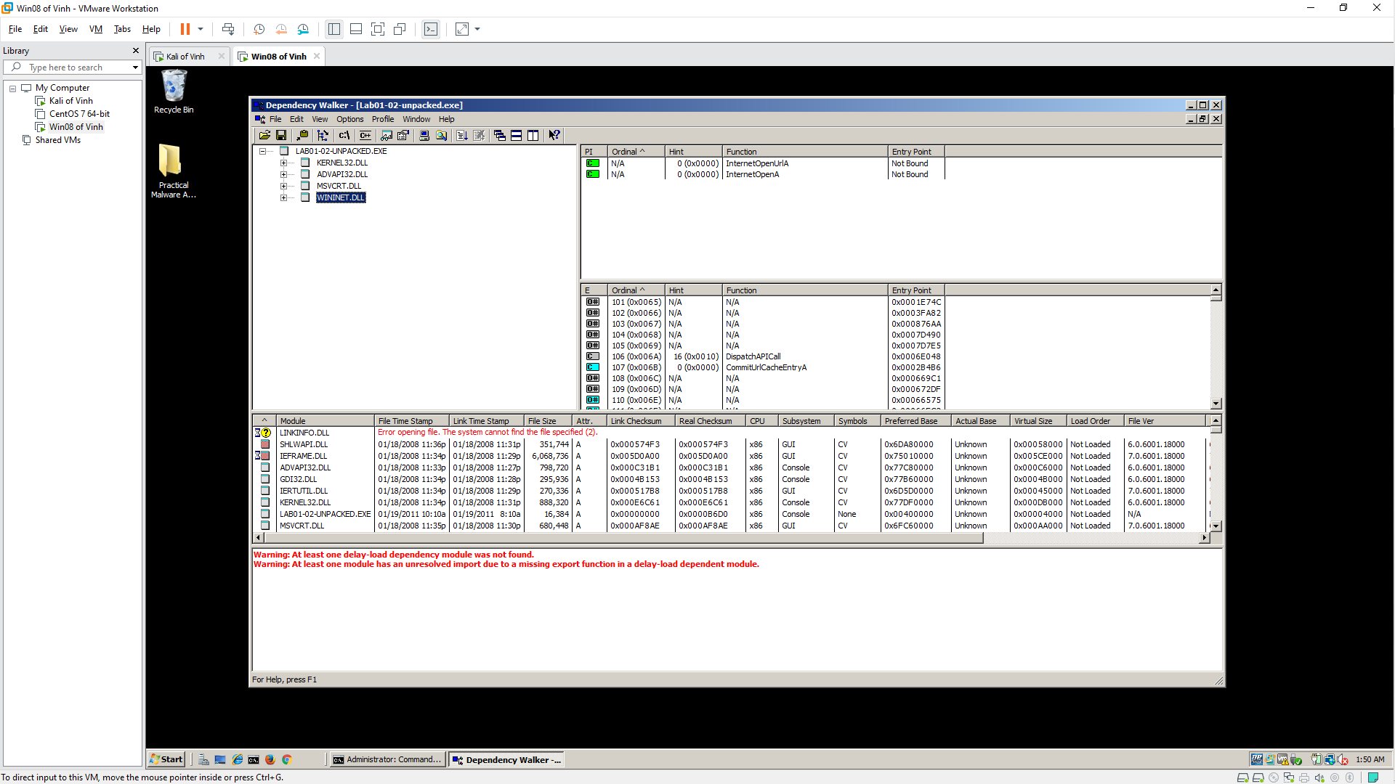

**Strings**

